For Immediate Release

RYAN Introduces New Lawnaire ZTS Stand-On Aerator

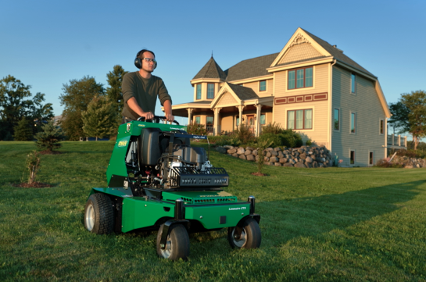
The new RYAN® Lawnaire® ZTS stand-on aerator
Highlights:
- The Lawnaire® ZTS is the first ever stand-on aerator from RYAN®.
- The innovative, low-maintenance design is highlighted by a hassle-free drivetrain with an automatic chain tensioning system and multiple easy-access panels to keep out debris.
- Performance features include a shock-absorbing operator platform, an aeration depth stop and an ergonomic, rapid hydraulic tine lift.
JOHNSON CREEK, Wis.– RYAN®, the leading manufacturer of turf renovation equipment for rental, golf, sports and lawn care professionals, is excited to introduce the brand-new Lawnaire® ZTS stand-on aerator.
The first of its kind from RYAN®, the Lawnaire ZTS brings a new level of efficiency and profitability to lawn care professionals. The Lawnaire ZTS includes:
- Revolutionary automatic chain-tensioning system
- Sturdy, shock-absorbing operator platform
- Intuitive drive controls and hassle-free maintenance access panels
- Low center of gravity for optimum maneuverability
- Fast hydraulic tine lift and precise aeration depth stop
- Powerful and nimble zero-turn drive at up to seven miles per hour

The quickness and intuitive controls of the Lawnaire ZTS also make it ideal for the rental market, requiring less time and experience, while providing more comfort to the user.
“The Lawnaire ZTS brings a new level of excitement and innovation to the trusted RYAN brand,” says Matt Donohue, RYAN® Brand Director. “It’s truly a new way to think about aerating, and we’re confident that it will change the way people aerate.”
For more information about the Lawnaire ZTS and other RYAN® turf renovation equipment, visit www.ryanturf.com or find your nearest authorized dealer.
***
About RYAN®
For over 60 years professionals have reached for RYAN® turf renovation equipment to transform landscapes and maintain healthy, thick turf. The RYAN® line of turf renovation equipment includes: aerators, dethatchers/turf rakes, overseeders, sod cutters and other specialty products that serve the landscaping and grounds care professional. RYAN® turf renovation equipment is available through power equipment retailers and rental dealerships nationwide. Learn more about RYAN® by visiting www.rytanturf.com.

RYAN® is a registered trademark of Schiller Grounds Care, Inc.

About Schiller Grounds Care, Inc.
Schiller Grounds Care, Inc. designs and manufactures commercial and residential gardening and turf care equipment. Its product lineup includes zero-turn, stand-on and walk-behind mowers, multiuse tractors and attachments, sod cutters, tillers, aerators, lawn vacuums, turf overseeders, brush cutters and much more. Schiller Grounds Care products are sold under the BOB-CAT®, Classen®, Little Wonder®, Mantis®, RYAN® and Steiner® brand names.

Learn more about Schiller Grounds Care and its brands at www.schillergc.com.

Media Contact:
Scott Covelli
EPIC Creative
262-338-3700, ext. 264
scovelli@epiccreative.com

