RYAN, PARTICIPATED IN A LANDSCAPE SERVICE EVENT AT ARLINGTON NATIONAL CEMETERY

JOHNSON CREEK, WIS, JULY 18, 2017 — RYAN, a member of the National Association of Landscape Professionals, participated in Renewal & Remembrance at Arlington National Cemetery on Monday, July 17, 2017. This marks the 21st year that industry professionals have worked to help care for this national burial ground that serves as the final resting spot for more than 400,000 military service men and women and their spouses.

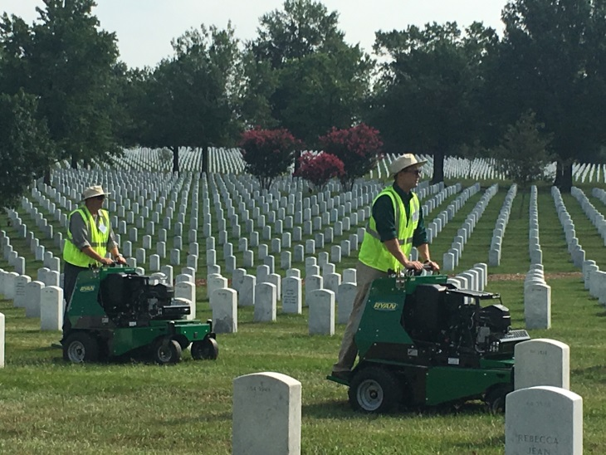
Every July, hundreds of landscape and lawn care professionals come from across the nation to Arlington National Cemetery to participate in Renewal & Remembrance which is organized by the National Association of Landscape Professionals. They volunteer their time mulching, upgrading sprinklers, cabling and installing lightning protection for the trees, pruning, planting, liming and aerating the soil.

“Our members look forward to this opportunity each year to give back to the individuals who made personal sacrifices for their country,” said Sabeena Hickman, CAE, NALP CEO. “We consider it a privilege to be able to volunteer our time and talents to improve the health and beauty of the grounds at Arlington National Cemetery, one of our nation’s most sacred places.”

“Schiller Grounds Care and RYAN are so honored to participate in the Renewal and Remembrance event at Arlington National Cemetery each year. Our employees are so proud to be involved in the turf maintenance and preserving such an amazing place, “said Pat Cappucci, President and COO of Schiller Grounds Care.

NALP members were also joined by members of the National Hispanic Landscape Alliance and the Professional Grounds Management Society.

The National Association of Landscape Professionals represents an industry that employs nearly 1 million landscape, lawn care, irrigation and tree care professionals who create and maintain healthy green spaces for the benefit of society and the environment. For more information, visit LoveYourLandscape.org.

Media Contact:
Scott Covelli
EPIC Creative
262-338-3700, ext. 264
scovelli@epiccreative.com

